Open Educational Resources Training Platform (OERTP)
Software Requirements Specification Plan
Release 1
Version 3
Contents
1 Introduction 6
1.1 Purpose 6
1.2 Scope 6
1.3 Overview 7
2 The Overall Description 8
2.1 Product Perspective 8
2.2 Product Functions 11
Table 1. Product Functions 12
2.3 Portal and content management 12
2.4 Authorization Matrix 12
2.5 Constraints 15
3 Detailed Functional Requirements 16
3.1 Manage Training Resource 16
3.2 Manage Sets of Categories 25
3.3 Manage Category 28
3.1 Manage Comment 34
3.2 Manage Event 39
3.3 Manage News 42
3.4 Manage Review 46
3.5 Manage Rating 50
3.6 User Management 51
3.7 Search 55
3.8 Utility 56
3.9 Miscellaneous 57
3.10 Portal and content management 60
4 Non Functional Requirements 64
4.1 Directory web services layer 64
4.2 Scalability and performance 64
4.3 Accessibility 64
4.4 Physical environment 64
4.5 Social environment 65
4.6 Organizational environment 65
4.7 Technical environment 65
4.8 User requirements 65
4.9 Usability requirements 65
4.10 Multilingualism requirements 66
5 Supporting Information 67
5.1 Appendix A: List of all compatible web browsers 67
5.1 Appendix B: Data Requirements 68
5.3 Appendix C: Change log history 79

Reference Documents
Please see the following documents for more information:
[SPMP] Software Project Management Plan
[SCMP] Software Configuration Management Plan
[SDDP] Software Design Descriptions Plan
[SQAP] Software Quality Assurance Plan
OERTP Strategy
OERTP wireframes

Introduction

Purpose
This Requirement Specification document describes the behavior of a proposed software product (herein referred as OERTP – Open Educational Resources Training Platform) that provides an expandable set of features that offers links to learning and capacity building resources in all development topics to better serve local people’s knowledge and skill acquisition needs in developing countries. The intended audience of this document is (1) the customer(s) who commissioned development of the product, or (2) any active member of UNESCO OERTP team who is responsible for the administration of the software. This plan was developed based on IEEE Std 830-1998 Software Requirements Specifications Plan.

Scope
The software shall be known as Open Educational Resources Training Platform (OERTP) shall be implemented as a set of modules within the Drupal 7 framework.
The intent of the proposed OERTP is fourfold: (1) to participate in an unprecedented, cross-sector, and UN (United Nations)-led development collaboration to reduce poverty; (2) to coordinate capacity building efforts, existing information centers and training as required by individual National Poverty Reduction plans; (3) to Access timely (up-to-the-minute) development information, technology, and organizations to maximize the training of local people; and (4) to Fill global development knowledge gaps via a responsive, flexible information warehouse that and can be tailored to the learning needs of local constituencies. For more information related to UNESCO’s strategy towards OERTP please refer to “OERTP Strategy 2013” document created by UNESCO.
Listed below are high level requirements expected from the OERTP tool;
- The OERTP tool should allow creating and managing training resources
- The OERTP tool should allow any authorized users to provide comments, to review and rate all the published training resources
- The OERTP tool should allow the training resources to be categories based on sets of categories created by UNESCO and also by partners and members.
- The OERTP tool should allow any authorized users to send private messages within the community.
- The OERTP tool should allow easily exporting and importing training resources from the OERTP tool.
- The OERTP tool should allow reusing OERTP directory content outside the existing OERTP platform via web services.

1.3 Overview
The requirements specification document is organized such that the initial sections detail the general behaviors and characteristics of the OERTP tool, while later sections detail more specific (and technical) software requirements and characteristics.
Apart from requirement specifications, the design descriptions can be found in SDDP. The, quality analysis is done using SQAP and the project is managed as per the SPMP.
Section 2 of the requirements specification document contains a high-level general description of the requirements that the proposed software suite must satisfy. This section is primarily intended for reference by the customer(s), as well as any potential administrator(s) of the system.
Section 3 and 4 of the requirements specification document contains descriptions of the specific software requirements, both functional and non-functional, as outlined in section 2. This section is primarily intended for reference by the development team responsible for implementing the initial release version of the product, as well as any potential developer(s) who intend on expanding the functionality of the product in future release versions.
Section 5 of the requirements specification document contains supporting information such as the appendices referenced throughout this document.

The Overall Description

Product Perspective
OERTP is a combination of a directory of training resources, portal and collaborative space of UNESCO partners and communities of practice. Primary goal of the OERTP platform is to provide a directory of links to training and learning resources to the wide public, enable community of professionals to propose references (links) to new resources to the directory, organize existing links using their own personalized categories and reuse OERTP directory content outside the existing OERTP platform.
Training Resource: Training Resource is the core of OERTP Platform. Training Resource contains metadata and a link to where the content is hosted. Training Resources are organized using different sets of categories. One training resource can have one or more sets of categories. Only registered users to OERTP tool can create a training resource. Registered users can provide comments, rate and review the training resource.
Below is an abstract model which displays training resource as one business entity and its relationship with other entities within the OERTP tool. This model is only for high level understanding.
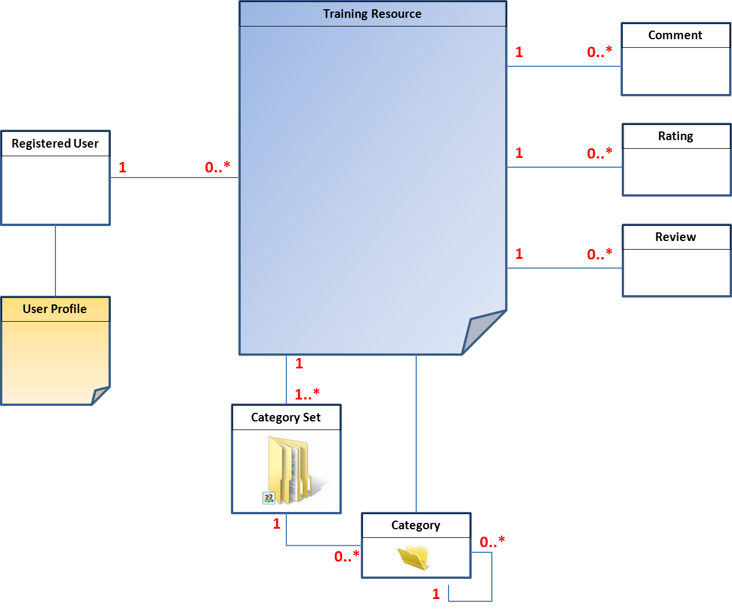
Figure 1. Abstract model of Training Resource
User: OERTP tool can primarily be accessed by two types of users. One is an anonymous user and other is a registered user. There can be 5 different types of registered users based on different profiles/roles. They are Administrator, Partner, Editor, Member and Reviewer. Partners are further classified as certified partners and non-certified partners. Section 2.3 provides authorization matrix for each of these roles.

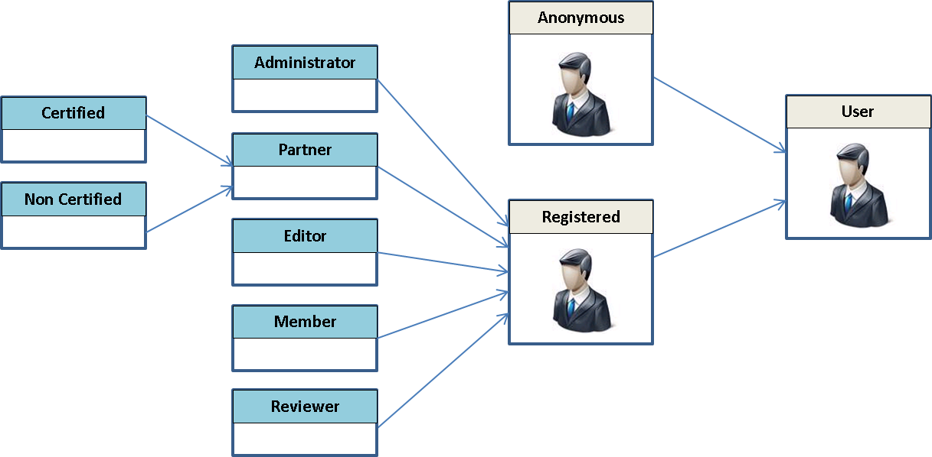
Figure 2. User Categories
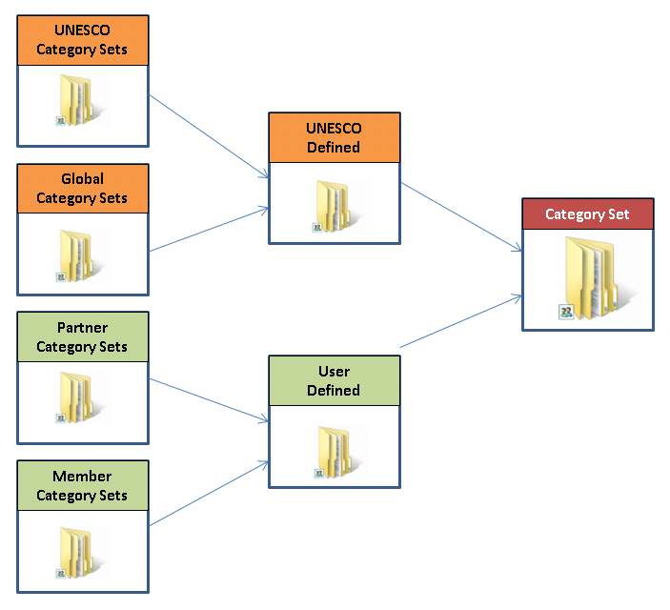
Category Sets: Category sets are high level grouping of training resources based on certain themes like Education, Science etc. In technical terms they can be considered as set of root categories with its own meta data which in turn includes list of categories and sub categories. Primarily there are two types of sets of categories. One defined by UNESCO and other defined by any registered users. Sets of categories created by registered users can be further classified as partner defined sets of categories and member defined sets of categories. UNESCO defined sets of categories are further classified as UNESCO set of categories and Global set of categories. Figure 3. Category Set
Category: Category is again based on certain low level themes used for grouping training resources but they fall under broad themes defined as category sets. Each category can again have sub category and so on. Training Resource can be assigned to unlimited number of categories. Any registered user can propose new categories to UNESCO’s sets of categories (subject to validation).
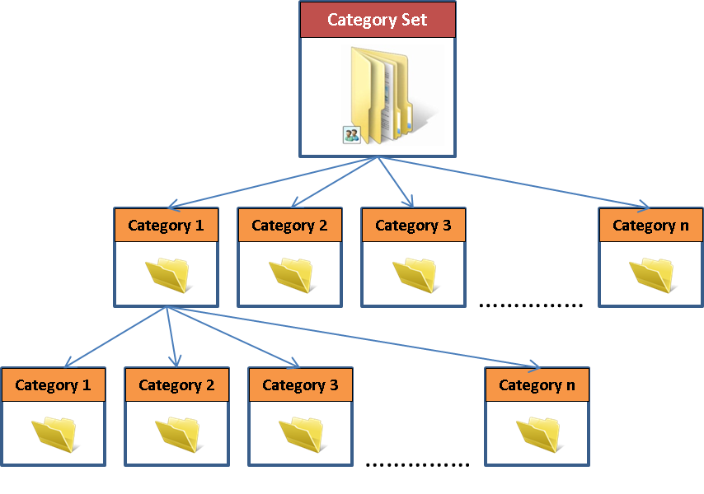
Apart from providing the training resources, the OERTP tool will also provide a collaborative space for all registered users to exchange ideas using personal messaging tool within OERTP, provide comments to the training resources,rate the training resources Figure 3. Category and provide reviews. Details on each of these functionalities are covered in subsequent sections of this document.

Product Functions
The main functions along with the use cases are summarized in the table below. The forth column provides business criticality for each function.
No | Functions | Use Cases | Business Criticality
1 | Manage Training Resource | Create Training Resource | High
1 | Manage Training Resource | Update Training Resource | High
1 | Manage Training Resource | Delete Training Resource | High
1 | Manage Training Resource | Validate Training Resource | High
1 | Manage Training Resource | View Training Resource | High
2 | Manage Sets of Categories | Create Sets of Categories | High
2 | Manage Sets of Categories | Update Sets of Categories | High
2 | Manage Sets of Categories | Delete Sets of Categories | High
3 | Manage Category | Create Category | High
3 | Manage Category | Update Category | High
3 | Manage Category | Delete Category | High
3 | Manage Category | Suggest Category | High
3 | Manage Category | Validate Category | High
4 | Manage Comment | Post Comment | Medium
4 | Manage Comment | Validate Comment | Medium
4 | Manage Comment | Delete Comment | Medium
4 | Manage Comment | View Comment | Medium
5 | Manage Ratings | Rate Training Resource | Medium
6 | Manage Review | Create Review | Medium
6 | Manage Review | Edit Review | Medium
6 | Manage Review | Delete Review | Medium
6 | Manage Review | View Review | Medium

No | Functions | Use Cases | Business Criticality
7 | User Management | Register to OERTP site | High
7 | User Management | Edit User Profile | High
7 | User Management | View User Profile | High
8 | Manage News | Add News | Medium
8 | Manage News | Edit News | Medium
8 | Manage News | Delete News | Medium
8 | Manage News | View News | Medium
9 | Manage Events | Add Event | Medium
9 | Manage Events | Edit Event | Medium
9 | Manage Events | Delete Event | Medium
9 | Manage Events | View Event | Medium
10 | Search | Basic Search | High
10 | Search | Advance Search | High
11 | Utility | Export Training Resource(s) | High
11 | Utility | Import Training Resource(s) | High
11 | Utility | Syndicate Training Resource(s) | High
12 | Miscellaneous | Subscribe to notifications | Medium
12 | Miscellaneous | Post internal messages | Medium
12 | Miscellaneous | Automated Correspondence | Medium
12 | Miscellaneous | Automated Link Checking | Medium

Table 1. Product Functions

Portal and content management
Apart from above functions there are content pages and data blocks in the OERTP tool which are listed explained in detail in sections 3.10.

Authorization Matrix
This section provide authorization matrix based on functions listed in section 2.2
Functions | Anonymous | Member | Partner (C) | Partner (NC) | Editor | Reviewer | Admin
Manage Training Resource
Create Training Resource |  | ☑ | ☑ | ☑ | ☑ | ☑ | ☑
Update Training Resource |  | ☑ | ☑ | ☑ | ☑ | ☑ | ☑
Delete Training Resource |  | ☑ | ☑ | ☑ | ☑ |  | ☑
Validate Training Resource |  |  |  |  | ☑ |  | ☑
View Training Resource | ☑ | ☑ | ☑ | ☑ | ☑ | ☑ | ☑
Manage Sets of Categories
Create Sets of Categories |  | ☑ | ☑ | ☑ | ☑ | ☑ | ☑
Update Sets of Categories |  | ☑ | ☑ | ☑ | ☑ | ☑ | ☑
Delete Sets of Categories |  | ☑ | ☑ | ☑ | ☑ | ☑ | ☑
Manage Category
Create Category |  | ☑ | ☑ | ☑ | ☑ |  | ☑
Update Category |  | ☑ | ☑ | ☑ | ☑ |  | ☑
Delete Category |  | ☑ | ☑ | ☑ | ☑ |  | ☑
Suggest Category |  | ☑ | ☑ | ☑ | ☑ | ☑ | ☑
Validate Category |  |  |  |  | ☑ |  | ☑
Manage Comment
Post Comment |  | ☑ | ☑ | ☑ | ☑ | ☑ | ☑
Validate Comment |  |  |  |  | ☑ |  | ☑
Delete Comment |  | ☑ | ☑ | ☑ | ☑ | ☑ | ☑
View Comment | ☑ (only validated comments) | ☑ | ☑ | ☑ | ☑ | ☑ | ☑
Manage Ratings
Rate Training Resource |  | ☑ | ☑ | ☑ | ☑ | ☑ | ☑
Manage Review
Create Review |  | ☑ | ☑ | ☑ | ☑ | ☑ | ☑
Edit Review |  | ☑ | ☑ | ☑ | ☑ | ☑ | ☑
Delete Review |  | ☑ | ☑ | ☑ | ☑ | ☑ | ☑
User Management
Register to OERTP | ☑
Edit User Profile |  | ☑ | ☑ | ☑ | ☑ | ☑ | ☑
View User Profile | ☑ | ☑ | ☑ | ☑ | ☑ | ☑ | ☑
Manage News
Add News |  |  |  |  | ☑ |  | ☑
Edit News |  |  |  |  | ☑ |  | ☑
Delete News |  |  |  |  | ☑ |  | ☑
View News | ☑ | ☑ | ☑ | ☑ | ☑ | ☑ | ☑
Manage Events
Add Event |  | ☑ | ☑ | ☑ | ☑ | ☑ | ☑
Edit Event |  | ☑ | ☑ | ☑ | ☑ | ☑ | ☑
Delete Event |  | ☑ | ☑ | ☑ | ☑ | ☑ | ☑
View Event | ☑ | ☑ | ☑ | ☑ | ☑ | ☑ | ☑
Search
Basic Search | ☑ | ☑ | ☑ | ☑ | ☑ | ☑ | ☑
Advance Search | ☑ | ☑ | ☑ | ☑ | ☑ | ☑ | ☑
Utility
Export Training Resource(s) |  | ☑ | ☑ | ☑ | ☑ | ☑ | ☑
Import Training Resource(s) |  |  |  |  |  |  | ☑
Syndicate Training Resource(s) | ☑ | ☑ | ☑ | ☑ | ☑ | ☑ | ☑
Miscellaneous
Subscribe to notifications |  | ☑ | ☑ | ☑ | ☑ | ☑ | ☑
Post internal messages |  | ☑ | ☑ | ☑ | ☑ | ☑ | ☑

Functions | Anonymous | Member | Partner (C) | Partner (NC) | Editor | Reviewer | Admin
In focus | ☑ | ☑ | ☑ | ☑ | ☑ | ☑ | ☑
Promote Us | ☑ | ☑ | ☑ | ☑ | ☑ | ☑ | ☑
Training on Demand | ☑ | ☑ | ☑ | ☑ | ☑ | ☑ | ☑
Web Services | ☑ | ☑ | ☑ | ☑ | ☑ | ☑ | ☑
About | ☑ | ☑ | ☑ | ☑ | ☑ | ☑ | ☑
FAQ | ☑ | ☑ | ☑ | ☑ | ☑ | ☑ | ☑
Glossary | ☑ | ☑ | ☑ | ☑ | ☑ | ☑ | ☑
Contact | ☑ | ☑ | ☑ | ☑ | ☑ | ☑ | ☑
Partner | ☑ | ☑ | ☑ | ☑ | ☑ | ☑ | ☑
Disclaimer | ☑ | ☑ | ☑ | ☑ | ☑ | ☑ | ☑
Terms of Use | ☑ | ☑ | ☑ | ☑ | ☑ | ☑ | ☑
Acknowledge | ☑ | ☑ | ☑ | ☑ | ☑ | ☑ | ☑
Editor Chaise | ☑ | ☑ | ☑ | ☑ | ☑ | ☑ | ☑
Latest News | ☑ | ☑ | ☑ | ☑ | ☑ | ☑ | ☑
Latest Added | ☑ | ☑ | ☑ | ☑ | ☑ | ☑ | ☑
Latest Reviews | ☑ | ☑ | ☑ | ☑ | ☑ | ☑ | ☑
Last Viewed | ☑ | ☑ | ☑ | ☑ | ☑ | ☑ | ☑
Category Sets | ☑ | ☑ | ☑ | ☑ | ☑ | ☑ | ☑
Community View | ☑ | ☑ | ☑ | ☑ | ☑ | ☑ | ☑
Directory Stats | ☑ | ☑ | ☑ | ☑ | ☑ | ☑ | ☑
Upcoming Events | ☑ | ☑ | ☑ | ☑ | ☑ | ☑ | ☑
Follow Us | ☑ | ☑ | ☑ | ☑ | ☑ | ☑ | ☑
UNESCO Space | ☑ | ☑ | ☑ | ☑ | ☑ | ☑ | ☑
Partner List | ☑ | ☑ | ☑ | ☑ | ☑ | ☑ | ☑
UNESCO OERTP | ☑ | ☑ | ☑ | ☑ | ☑ | ☑ | ☑
Table 2. Authorization Matrix

Constraints
As requested by the customer, the application needs to be developed for web-based and based on Free and Open Source Software (FOSS). The server-side system is required to run on Apache with PHP, in conjunction with MySQL server.
The application will need to be modular to comply with Drupal standards. User management will be handled by Drupal, thus the application will require integration with the Drupal database for authentications and manipulations. Drupal uses PHP code for its modules, and thus the modules shall be developed (if any) using PHP.
The client for OERTP tool will be a web browser. For list of all compatible web browsers please refer to Appendix III.
The customer expressed an interest in accessing the OERTP tool from mobile devices. The most common approach to allow compatibility with multiple mobile platforms is to make use of their own mobile Internet browsers as a means to interface between user and the system. The interface will be constrained to the screen sizes of the device itself. Application size and speed will also be constrained by the amount of memory and processing power of the mobile phones running them. For list of all compatible web browsers please refer to Appendix III.

Detailed Functional Requirements
This section details all OERTP functionality listed in section 2.2

Manage Training Resource

Create Training Resource
Brief Description | This use case will allow any registered user to OERTP site to create or suggest a new training resource.
Actors | All registered users can create or suggest new training resource
Pre-Condition | No training resource exist
Post Condition | - New training resource is created and available on OERTP tool.  - In case of member and non-certified partner suggesting a new training resource, email request is send to the authorized user for validation and a validation task is created in the OERTP for the authorized user.  - In case of member and non-certified partner suggesting a new training resource, email is send to these users mentioning that the training resource that they suggested will be available on the OERTP subject to validation.

Basic Flow of Event
1 | Registered user clicks on the link “Create New Training Resource” or “Suggest New Training Resource” to create a new training resource.
2 | System displays create new training resource page.
3 | User enters all the mandatory data required for the system to create a new training resource. For set of data required for creating a training resource please refer to Appendix 5.1.1.
4 | User clicks on submit to create a new training resource.
5 | System checks if all the mandatory fields required to create a new training resource are entered by the user. If any mandatory field is missing, system informs the user about the same.
6 | If all the mandatory fields are entered, before creating a new training resource system checks if the link provided for the training resource is working correctly or broken. If the link is broken system will inform the user before creating the training resource. What it means that system will inform? Is it going to let user submit the resource or will stop the action? URL checking at this point could be an issue if the link is temporarily unavailable or blocked by local firewall etc.
7 | If all the mandatory fields and the link to training resource are validated by the system, before creating a new training resource the system will check the profile of the user.  - If the user is a member or non-certified partner the system will show a message to the user that  the training resource will be available on the OERTP tool subject to validation. Email message is also sent to the user informing that the training resource will be available subject to validation.  - If the user creating the training resource is other than member or non-certified partner, the  system will create the new training resource and publish the same to the OERTP tool.
8 | Once the new training resource is published to the OERTP tool, the system will check if any users have subscribed to sets of categories which are associated to this training resource and accordingly send the notification email about the new resource availability on the OERTP tool along with the link to the resource.

Exceptions
1 | If while creating a new resource, the sets of categories the user wants to select for the new resource does not exist in existing sets of categories the user can create a new sets of category by clicking on the link “suggest new sets of category or category”
2 | The system will present “create new sets of categories” or category screen as an overlay option (pop-up) to create new sets of category or new categories. For more information on creating new sets of category or category please refer to the use case “create new sets of categories” or “create category”
3 | Once the user creates the new sets of category, the overlay page will be closed and the new sets of category will be available for selection in the new resource that he was creating.

Special Requirements
If member has created their own set of categories they will have option when adding a Training Resource to categorize it using their sets of categories but this is optional. Categorization using the “General” set of categories is mandatory. Categorization using “UNESCO” set of categories is optional

Data Requirements
1 | For list of fields required to create a new training resource please refer to Appendix 5.1.1.

UI Layout
Please refer to the wireframe diagrams document “OERTP wireframes” which is a UNESCO internal document. The wireframe will provide general placements of fields as expected for training resource page. This section will be updated with final screen layouts as and when this feature is developed in OERTP platform.

Edit Training Resource
Brief Description | This use case will allow any authorized user (please refer to authorization matrix for list of authorized users) to edit a training resource.
Actors | All authorized users as per the authorization matrix can edit a training resource. Members can only edit their own resources.
Pre-Condition | Training resource already exists and validated.
Post Condition | Updates made to the training resource are available on OERTP tool.  - In case of member and non-certified partner, any updates made to the training resource, email request is send to the authorized user for validation and a validation task is created in the OERTP for the authorized user responsible to validate the training resource.  - In case of member and non-certified partner, any updates made to the training resource, email is send to these users mentioning that the updates will be available on the OERTP subject to validation.  - Till the time update made to the training resource is not validated, the system will display the last validated/published version on OERTP tool.

Basic Flow of Event
1 | Registered user clicks on the link “Edit Training Resource” to update existing resource.
2 | System displays training resource page in edit mode.
3 | User make updates to existing data entered as part of last update.
4 | User clicks on submit to update the new training resource.
5 | System checks if all the mandatory field required to update the training resource are entered by the user. If any mandatory field is missing, system informs the user about the same.
6 | If all the mandatory fields are entered, before updating the new training resource system checks if the link provided for the training resource is working correctly or broken. If the link is broken system will inform the user before updating the training resource.
7 | If all the mandatory fields and the link to training resource are validated by the system, before updating the training resource the system will check the profile of the user.  - If the user is a member or non-certified partner the system will show a message to the user that the updates made to the training resource are saved but will be available on the OERTP tool subject to validation. Email message is also sent to the user informing that the updates will be available subject to validation.  - If the user creating the training resource is other than member or non-certified partner, the system will create the new training resource and publish the same to the OERTP tool.
8 | Once the new training resource is published to the OERTP tool, the system will check if any users have subscribed to the categories which are associated to this training resource and accordingly send the notification email about the update done to the training resource on the OERTP tool along with the link to the resource.

Exceptions
1 | If while updating a new resource, the sets of categories the user wants to select for the resource does not exist in existing sets of categories the user can create a new sets of categories by clicking on the link create new sets of categories or category.
2 | The system will display “create new sets of categories” or category screen as an overlay option (pop-up) to create new sets of categories or categories. For more information on creating new sets of categories or category please refer to the use case “create new sets of categories” or “create category”
3 | Once the user creates the new sets of categories, the overlay page will be closed and the new sets of categories will be available for selection in the new resource that he was creating.

Special Requirements
None

Data Requirements
1 | For list of fields required to update a new training resource please refer to Appendix 5.1.1.

UI Layout
Please refer to the wireframe diagrams document “OERTP wireframes”. The wireframe will provide general placements of fields as expected for training resource page. This section will be updated with final screen layouts as and when this feature is developed in OERTP platform.

Delete Training Resource
Brief Description | This use case will allow any authorized user (please refer to authorization matrix for list of authorized users) to delete a training resource or request deletion of training resource.
Actors | All authorized users as per the authorization matrix can delete the training resource. Members can suggest deleting only their own resources.
Pre-Condition | Training resource already exists and validated.
Post Condition | Deletion request are subject to following conditions.  - In case of member and non-certified partner, any deletion request made to the training resource, email request is send to the authorized user for validation and a validation task is created in the OERTP for the authorized user.  - In case of member and non-certified partner, any deletion request made to the training resource, email is send to these users mentioning that the delete request is subject to validation.  - Till the time the request is not validated, the system will display the last validated/published version on OERTP tool.

Basic Flow of Event
1 | Registered user clicks on the link “Delete Training Resource” or “Request Deletion for Training Resource” to delete existing resource.
2 | System request confirmation for deletion. User confirms deletion.
3 | If the user is a member or non-certified partner the system will show a message to the user that your request for deletion of training resource is subject to validation. Email message is also sent to the user informing that your request for deletion will be available subject to validation.
7 | If the user creating the training resource is other than member or non-certified partner, the system will delete the training resource.
8 | Once the training resource is deleted system will inform the user and also send the confirmation email.

Exceptions
1 | None

Special Requirements
- Administrators and Editors should have the possibility to delete one or more than one training resources at a same time.

Data Requirements
1 | None

UI Layout
Please refer to the wireframe diagrams document “OERTP wireframes”. The wireframe will provide general placements of fields as expected for training resource page. This section will be updated with final screen layouts as and when this feature is developed in OERTP platform.

Validate Training Resource

Brief Description | This use case will allow any authorized user (please refer to authorization matrix for list of authorized users) to validate (Validation for new creation of training resource, updation or deletion of existing training resource) the training resource.
Actors | All authorized users as per the authorization matrix can validate the training resource.
Pre-Condition | New training resource is created or request for update or deletion for existing training resource is made by a user having role of a member or non-certified partner.  The user authorized for validating the training resource is notified by email and a task is created in OERTP tool.
Post Condition | The training request is either validated or rejected by the user.  The training resource is published to OERTP tool.  The user creating the training resource or requesting update or deletion to existing training resource is notified by mail once the training request is validated or rejected.

Basic Flow of Event
1 | Authorized user having rights to validate the training request can either click on the link from the email or login to OERTP tool and select the task for validation.
2 | Clicking on the link from the email will open the training resource page once the user is authenticated to the OERTP tool. User can also click on the task assigned to him in the OERTP tool to validate the request.
3 | Once the authorized user is on the training resource page, the user will have the option to validate or reject the request. User will also have an option to provide comments before validating or rejecting the training resource.
4 | Once the user clicks on validate or reject link/button the system will request for confirmation from the user.
5 | Once confirmed by the user, the system will validate or reject the request and send a mail to owner of the request.

Exceptions
1 | None

Special Requirements
- The system should provide the authorized user responsible to validate the request to select more than one training resource for validation.

Data Requirements
1 | For list of fields please refer to Appendix 5.1.1.

UI Layout
Please refer to the wireframe diagrams document “OERTP wireframes”. The wireframe will provide general placements of fields as expected for training resource page. This section will be updated with final screen layouts as and when this feature is developed in OERTP platform.

View Training Resource
Brief Description | This use case will allow any user having access to web to view all the training resources that are published (validated).
Actors | All users having access to web.
Pre-Condition | The training resource is published.  The user should be using only compatible browsers mentioned in Appendix III
Post Condition | The user was able to view the training resource page

Basic Flow of Event
1 | Any user having access to the web has to type the url for OERTP tool
2 | Once the user is on the OERTP tool, the user can view the training resource through various means as indicated through this document.

Exceptions
1 | None

Special Requirements
- The user should able to access the training resource page via mobile devices.

Data Requirements
1 | For list of fields please refer to Appendix 5.1.1.

UI Layout
Please refer to the wireframe diagrams document “OERTP wireframes”. The wireframe will provide general placements of fields as expected for training resource page. This section will be updated with final screen layouts as and when this feature is developed in OERTP platform.

Manage Sets of Categories

Create Sets of Categories
Brief Description | This use case will allow any authorized use (refer to authorization matrix) to create new sets of categories.
Actors | Authorized users (please refer to authrorization matrix)
Pre-Condition | None
Post Condition | Sets of Categories is created.

Basic Flow of Event
1 | Authorized user click on Create Set of Categories.
2 | System displays “Create Set of Categories” page
3 | User enters all the mandatory information and submits.
4 | System checks if all the mandatory information is entered.
5 | System creates new set of categories.

Exceptions
1 | No validation process is required for sets of categoires.

Special Requirements
None

Data Requirements
1 | For list of fields required to create a new sets of categories please refer to Appendix 5.1.2.

UI Layout
Please refer to the wireframe diagrams document “OERTP wireframes”.This section will be updated with final screen layouts as and when this feature is developed in OERTP platform

Update Sets of Categories
Brief Description | This use case will allow the owner of the sets of category to update sets of categories.
Actors | Authorized users (please refer to authrorization matrix)
Pre-Condition | Sets of Categories to be updated already exist.
Post Condition | Sets of Categories are updated.

Basic Flow of Event
1 | Authorized user click on Update Sets of Categories.
2 | System displays “Update Sets of Categories” page.
3 | User updates sets of categories data and submits.
4 | System checks if all the mandatory information is entered.
5 | System updates sets of categories data.

Exceptions
1 | None

Special Requirements
None

Data Requirements
1 | For list of fields please refer to Appendix 5.1.2

UI Layout
Please refer to the wireframe diagrams document “OERTP wireframes” from UNESCO. This section will be updated with final screen layouts as and when this feature is developed in OERTP platform

Delete Sets of Categories
Brief Description | This use case will allow the owner of the sets of category to delete the sets of category
Actors | Owner of sets of categories.
Pre-Condition | Sets of Categories to be deleted already exist.
Post Condition | Sets of Categories is deleted. All categories within deleted set of categories will be deleted too.

Basic Flow of Event
1 | Authorized user click on Delete Sets of Categories.
2 | System display set of categories list.
3 | User selects from the list sets of categories to be deleted. The user can select one of more than sets of categories for deletion.
4 | System asks for confirmation from the user before deleting.
5 | User confirms for deletion.
6 | System deletes all the sets of categories selected for deletion.

Exceptions
1 | None

Special Requirements
1 | If the sets of categories requested for deletion are associated with certain training resources then after deletion the system will remove the association with training resource.
2 | If the sets of categories already have categories associated. After deletion, those categories are no longer associated with the deleted sets of categories.

Data Requirements
1 | -

UI Layout
Please refer to the wireframe diagrams document “OERTP wireframes ”. This section will be updated with final screen layouts as and when this feature is developed in OERTP platform

Manage Category

Create Category
Brief Description | This use case will allow any authorized use (refer to authorization matrix) to create new category under his own sets of categories.
Actors | Authorized users (please refer to authrorization matrix)
Pre-Condition | Sets of Categories exist to which the new category will be associated.
Post Condition | - New Category is created.  - New Category is associated to sets of categories.

Basic Flow of Event
1 | Authorized user click on Create Category.
2 | System displays “Create Category” page.
3 | User enters all the mandatory information and submits.
4 | System checks if all the mandatory information is entered.
5 | System create new category.

Exceptions
1 | None

Special Requirements
- User can only associate category to his own sets of categories.
- User can make a copy of category from one set of categories to another set of categories but when copy is created and assigned to another set of categories this category is not associated with the original category.
- Categories can contain subcategories. There is no limit on categories tree depth.

Data Requirements
1 | For list of fields please refer to Appendix 5.1.3

UI Layout
Please refer to the wireframe diagrams document “OERTP wireframes ”. This section will be updated with final screen layouts as and when this feature is developed in OERTP platform

Update Category
Brief Description | This use case will allow the owner of the category to update the category data.
Actors | Authorized User (please refer to authorization matrix)
Pre-Condition | Category to be updated already exists.
Post Condition | Category data is updated

Basic Flow of Event
1 | Authorized user click on Update Category link.
2 | System displays “Update Category” page
3 | User updates category data and submits
4 | System checks if all the mandatory information is entered.
5 | System updates category data.

Exceptions
1 | None

Special Requirements
- Use can only update their own categories belonging to their own sets of categories.

Data Requirements
1 | For list of fields please refer to Appendix 5.1.3

UI Layout
Please refer to the wireframe diagrams document “OERTP wireframes ”.This section will be updated with final screen layouts as and when this feature is developed in OERTP platform

Delete Category
Brief Description | This use case will allow the owner of the category to delete the category.
Actors | Authorized User (please refer to authorization matrix)
Pre-Condition | Category to be deleted already exist
Post Condition | Category is deleted.

Basic Flow of Event
1 | Authorized user click on Delete Category.
2 | System display list of categories.
3 | User selects from the list all the categories to be deleted. The user can select one of more categories for deletion.
4 | System asks for confirmation from the user before deleting.
5 | User confirms for deletion.
6 | System deletes all the selected categories.

Exceptions
1 | None

Special Requirements
- Use can only update his own categories
- If a category has sub categories associated. After deletion, those sub categories are no longer associated with the deleted categories.
- If the categories for deletion are associated with certain training resources then after deletion the system will remove the association.

Data Requirements
1 | For list of fields please refer to Appendix 5.1.3.

UI Layout
Please refer to the wireframe diagrams document “OERTP wireframes ”. This section will be updated with final screen layouts as and when this feature is developed in OERTP platform

Suggest Category
Brief Description | This use case will allow any authorized use to suggest a new category under UNESCO sets of categories (UNESCO and Global)
Actors | Any registered user.
Pre-Condition | UNESCO sets of categories (UNESCO and Global) exists.
Post Condition | - New Category is suggested under UNESCO defined sets of categories.  - Email request is send to the authorized user for validation and a validation task is  created in the OERTP for the authorized user. Email is also send to user creating/suggesting a new category mentioning that the category that they suggested will be available on the OERTP subject to validation.

Basic Flow of Event
1 | Authorized user click on suggest new category.
2 | System displays “Suggest Category” page.
3 | User enters all the mandatory information and submits
4 | System checks if all the mandatory information is entered and saves the information.
5 | System will show a message to the user that the new suggested category will be available on the OERTP tool subject to validation. Email message is also sent to the user informing that the category will be available subject to validation.

Exceptions
1 | None

Special Requirements
- Suggested category should only be associated to UNESCO defined (UNESCO or Global) sets of
categories.
- One category can be associated to more than one sets of categories.
- Categories can contain subcategories. There is no limit on categories tree depth

Data Requirements
1 | For list of fields please refer to Appendix 5.1.3

UI Layout
Please refer to the wireframe diagrams document “OERTP wireframes ”. This section will be updated with final screen layouts as and when this feature is developed in OERTP platform

Validate Category
Brief Description | This use case will allow any authorized user (please refer to authorization matrix for list of authorized users) to validate new category suggested under UNESCO and Global sets of categories
Actors | All authorized users as per the authorization matrix can validate category.
Pre-Condition | Authorized user was able to suggest a new category under UNESCO defined sets of categories .  The user authorized for validating the category is notified by email and a task is created in OERTP tool.
Post Condition | The category is either validated or rejected by the user.  The user creating the category is notified by mail once the category is validated or rejected.

Basic Flow of Event
1 | Authorized user having rights to validate category can either click on the link from the email or login to OERTP tool and select the task for validation.
2 | Clicking on the link from the email will open the category page once the user is authenticated to the OERTP tool. User can also click on the task assigned to him in the OERTP tool to validate the request.
3 | Once the authorized user is on the category page, the user will have the option to validate or reject the request. User will also have an option to provide comments before validating or rejecting the category.
4 | Once the user clicks on validate or reject link/button the system will request for confirmation from the user.
5 | Once confirmed by the user, the system will validate or reject the request and send a mail to owner of the request.

Exceptions
1 | None

Special Requirements
The system should provide the authorized user responsible to validate the request to select more than category for validation.

Data Requirements
1 | For list of fields please refer to Appendix 5.1.3.

UI Layout
Please refer to the wireframe diagrams document “OERTP wireframes ”. The wireframe will provide general placements of fields as expected for training resource page. This section will be updated with final screen layouts as and when this feature is developed in OERTP platform

Manage Comment

Post Comment
Brief Description | This use case will allow any authorized user to post comments for a training resource
Actors | Any register user to OERTP tool.
Pre-Condition | Training resource exist and user is on training resource page
Post Condition | Comment is successfully posted for the training resource.

Basic Flow of Event
1 | User enters the subject (title) and comment (description) and clicks on save
2 | System displays a message to the user saying that the comments will be displayed once they are validated.

Exceptions
1 | Members cannot comment their own submitted Training Resources

Special Requirements
1. The user should be able to post a new comment to the training resource or should be able to reply to an existing comment.
2. Treading option should be available.
3. Once the comments are posted it should show the name of the user (last name first name) and the time stamp of the new comment.
4. If the comment is not validated, the user posting the comment should still see the comment with a message pending validation and the comment should be highlighted.

Data Requirements
1 | For list of fields required to manage comments please refer to Appendix 5.1.4

UI Layout
Please refer to the wireframe diagrams document “OERTP wireframes ”. This section will be updated with final screen layouts as and when this feature is developed in OERTP platform

Validate Comment
Brief Description | This use case will allow any authorized user to validate comments posted against a training resource
Actors | User authorized to validate comments. Please refer to authorization matrix
Pre-Condition | 1. Comments to be validated are posted by the user  2. User authorized to validate the comment has received an email informing him about the new comments that are posted
Post Condition | User was able to validate the comments

Basic Flow of Event
1 | User can click on the email to go to the training resource page for which the comment was posted or directly login through the OERTP tool to see list of training resource where new comments are posted.
2 | Once on the training resource page, user can see all the new comments that are posted for that training resource.
3 | User can click on the validate link available against each comment to validate the comment.
4 | Alternatively the user can click on reject link available against each comment to reject the comment. If the comment is rejected the user who has posted the comment will be notified by email.

Exceptions
1 | None

Special Requirements
1. New comments which are not validated should be highlighted in different color from rest of the validated comments for the authorized to easily navigate through the new comments.

Data Requirements
1 | For list of fields please refer to Appendix 5.1.4.

UI Layout
Please refer to the wireframe diagrams document “OERTP wireframes ”. This section will be updated with final screen layouts as and when this feature is developed in OERTP platform

Delete Comment
Brief Description | This use case will allow the user who posted the comment or any authorized user to delete the comment.
Actors | User who posted the comment or any other authorized user ( refer to authorization matrix)
Pre-Condition | 1. Comment is posted.  2. The user is on the training resource page
Post Condition | Comment is deleted.

Basic Flow of Event
1 | User clicks on the delete link next to the comment to delete the comment.
2 | System asks for a confirmation before deleting the comment.
3 | User confirms deletion
4 | System deletes the comment.

Exceptions
1 | None

Special Requirements
1. Other than authorized users, users can only see the delete link for all the comments they have posted.

Data Requirements
1 | For list of fields please refer to Appendix 5.1.4.

UI Layout
Please refer to the wireframe diagrams document “OERTP wireframes ”. This section will be updated with final screen layouts as and when this feature is developed in OERTP platform

View Comment
Brief Description | This use case will allow all the registered users to the OERTP tool to view all the comments (only validated) posted against a training resource.
Actors | All registered users and anonymous users
Pre-Condition | 1. Training resource exist and comments are posted
Post Condition | 2. User was able to view all the comments

Basic Flow of Event
1 | User clicks on the training resource page to view the comments.

Exceptions
1 | None

Special Requirements
1. User should be provided with the option to see how many comments he would like to see on a page.

Data Requirements
1 | For list of fields please refer to Appendix 5.1.4.

UI Layout
Please refer to the wireframe diagrams document “OERTP wireframes ”. This section will be updated with final screen layouts as and when this feature is developed in OERTP platform

Manage Event

Create Event
Brief Description | This use case will allow any authorized user to create a new event.
Actors | Any authorized user (Please refer to authorization matrix)
Pre-Condition | 1. The event to be created does not exist  2. The user creating the event is logged into OERTP tool
Post Condition | New event is created.

Basic Flow of Event
1 | User click on create event link from the OERTP tool
2 | System displays create event page
3 | User enters all the data required to create a new event and click on submit
4 | System checks if all the mandatory information to create an event is entered.
5 | If all the mandatory fields are entered system creates a new event and informs the user.

Exceptions
1 | None

Special Requirements
None

Data Requirements
1 | For list of fields please refer to Appendix 5.1.5.

UI Layout
Please refer to the wireframe diagrams document “OERTP wireframes ”.This section will be updated with final screen layouts as and when this feature is developed in OERTP platform

Edit Event
Brief Description | The use case will allow any authorized users to edit an event.
Actors | User who created an event or any authorized user (please refer to authorization matrix) who has permissions to edit an event.
Pre-Condition | 1. Event to be edited already exists.  2. User has logged to OERTP tool.
Post Condition | Event data is successfully updated.

Basic Flow of Event
1 | User clicks on edit link to edit an existing event.
2 | System display edit event page.
3 | User updates the event page and click on submit.
4 | System checks if all the mandatory fields required to update an event is entered.
5 | If all the mandatory data is entered system update the event and informs the user.

Exceptions
1 | None

Special Requirements
None

Data Requirements
1 | For list of fields please refer to Appendix 5.1.5.

UI Layout
Please refer to the wireframe diagrams document “OERTP wireframes ”. This section will be updated with final screen layouts as and when this feature is developed in OERTP platform

Delete Event
Brief Description | This use case will allow user to delete an existing event.
Actors | User who created an event and any authorized user (please refer to authorization matrix) who has permissions to edit an event
Pre-Condition | 1. Event to be deleted already exists.  2. User has logged to OERTP tool
Post Condition | Event was deleted.

Basic Flow of Event
1 | User selects the event to be deleted.
2 | System display event page.
3 | User clicks on delete to delete the event.
4 | System deletes the event and confirms the same to the user.

Exceptions
1 | None

Special Requirements
- User should be able to delete one or more than one event.

Data Requirements
1 | For list of fields please refer to Appendix 5.1.5.

UI Layout
Please refer to the wireframe diagrams document “OERTP wireframes ”. This section will be updated with final screen layouts as and when this feature is developed in OERTP platform

View Event
Brief Description | This use case will allow user to view an event already created.
Actors | Any user who can access OERTP tool.
Pre-Condition | Event already exists.
Post Condition | User was able to view event(s)

Basic Flow of Event
1 | User clicks on event page to view the event
2 | System displays the event page with list of latest events.
3 | User clicks on the event from the list.
4 | System display details event page.

Exceptions
1 | None

Special Requirements
1. UNESCO has requested to check if there are any out of the box modules for events which can display events in different formats like event calendar, by day, by month and by year.
2. System should be able to browse the events by month and by year.

Data Requirements
1 | For list of fields required to create a new training resource please refer to Appendix.

UI Layout
Please refer to the wireframe diagrams document “OERTP wireframes ”. This section will be updated with final screen layouts as and when this feature is developed in OERTP platform

Manage News

Create News
Brief Description | This use case will allow all authorized users to create news items.
Actors | Authorized users (refer to authorization matrix for list of user roles authorized to create news items)
Pre-Condition | 1. News items to be created do not exist.  2. User authorized to create a news items is logged in to the OERTP tool.
Post Condition | User is able to add a news item.

Basic Flow of Event
1 | User clicks on create news item to create a new news item.
2 | System display create news item page.
3 | User enters all the information required to create a news item and clicks on submit.
4 | Systems checks if all the mandatory information is entered in order to create a news items. If all the mandatory information is entered, System creates a news items and informs the user.

Exceptions
1 | None

Special Requirements
None

Data Requirements
1 | For list of fields please refer to Appendix 5.1.6.

UI Layout
Please refer to the wireframe diagrams document “OERTP wireframes ”.This section will be updated with final screen layouts as and when this feature is developed in OERTP platform

Edit News
Brief Description | This use case will allow user to edit an existing created news item.
Actors | Authorized users (refer to authorization matrix for list of user roles authorized to create news)
Pre-Condition | News item to be edited already exist.  User authorized to edit the news items is logged in to OERTP tool.
Post Condition | User was able to update the news item.

Basic Flow of Event
1 | User clicks on the news to edit.
2 | System displays edit news page.
3 | User update the news item information and click on submit
4 | System checks if all the mandatory information is entered. If all the mandatory information is entered the user save the information and informs the user.

Exceptions
1 | None

Special Requirements
None

Data Requirements
1 | For list of fields please refer to Appendix 5.1.6.

UI Layout
Please refer to the wireframe diagrams document “OERTP wireframes ”. This section will be updated with final screen layouts as and when this feature is developed in OERTP platform

Delete News
Brief Description | This use case will allow user to delete news item.
Actors | Authorized users (refer to authorization matrix for list of user roles authorized to create news)
Pre-Condition | News item to be deleted already exist.  User authorized to delete the news items is logged in to OERTP tool.
Post Condition | User was able to delete the news item.

Basic Flow of Event
1 | User selects the news item to be deleted. User has the option to select the news item from the list of news item or click on the news item to go to the details page and then select the delete option.
2 | System confirms the deletion with the user before deleting the news item.

Exceptions
1 | None

Special Requirements
1. User should be able delete more than one news items by the selecting the news items for the list.

Data Requirements
1 | For list of fields please refer to Appendix 5.1.6.

UI Layout
Please refer to the wireframe diagrams document “OERTP wireframes ”.This section will be updated with final screen layouts as and when this feature is developed in OERTP platform.

View Event
Brief Description | This use case will allow viewing news items already created.
Actors | Any user who can access OERTP tool
Pre-Condition | News items already exist
Post Condition | User was able to view news items

Basic Flow of Event
1 | User clicks on news item page to view list of news items
2 | System displays news item page with list of latest news items
3 | User clicks on the news item from the list.
4 | System display details news item page.

Exceptions
1 | None

Special Requirements
User should be able to browse the news items by year.

Data Requirements
1 | For list of fields please refer to Appendix 5.1.6.

UI Layout
Please refer to the wireframe diagrams document “OERTP wireframes ”. This section will be updated with final screen layouts as and when this feature is developed in OERTP platform

Manage Review

Create Review
Brief Description | This use case will allow authorized user to provide review for a training resource
Actors | Authorized users (refer to authorization matrix)
Pre-Condition | 1. Training resource exist.  2. User wants to review a training resource
Post Condition | User was able to successfully review a training resource.

 | Basic Flow of Event
1 | User clicks on the training resource for which the user wants to provide a review.
2 | System opens the training resource page.
3 | User clicks review link to provide review for the training resource. Review link should appear only to users who are authorized to create reviews.
4 | System open add review page.
5 | User enters the review and clicks on save.
6 | System checks if all mandatory information is entered before saving the review. If all mandatory information is entered, system saves the review and informs the user.

 | Exceptions
1 | None

Special Requirements
None

 | Data Requirements
1 | For list of fields please refer to Appendix.

UI Layout
Please refer to the wireframe diagrams document “OERTP wireframes ”. This section will be updated with final screen layouts as and when this feature is developed in OERTP platform

Edit Review
Brief Description | This use case will allow the user to edit his/her review
Actors | User who has submitted a review or any user authorized to edit a review (please refer to authorization matrix)
Pre-Condition | 1. Review to be edited already exists.  2. User wants edit the review
Post Condition | 3. User was able to successfully edit the review

 | Basic Flow of Event
1 | User click on the edit link next to review that was submitted.
2 | System opens the review page on edit mode.
3 | User updates the review and saves.
4 | System checks if all the mandatory information is entered. If yes, then system save the review and inform the user.

 | Exceptions
1 | None

Special Requirements
None

Data Requirements
1 | For list of fields please refer to Appendix.

UI Layout
Please refer to the wireframe diagrams document “OERTP wireframes ”. This section will be updated with final screen layouts as and when this feature is developed in OERTP platform

Delete Review
Brief Description | This use case will allow the user to delete his/her review.
Actors | User who has submitted a review or any user authorized to delete a review (please refer to authorization matrix)
Pre-Condition | 1. Review to be deleted already exists.  2. User wants delete the review.
Post Condition | 3. User was able to successfully delete the review.

 | Basic Flow of Event
1 | User click on the delete link next to review that was submitted.
2 | System ask for confirmation from the user if the user wants to delete the review
3 | User confirms deletion.
4 | System delete the review and informs the user

Exceptions
1 | None

Special Requirements
None

Data Requirements
1 | For list of fields please refer to Appendix.

UI Layout
Please refer to the wireframe diagrams document “OERTP wireframes ”. This section will be updated with final screen layouts as and when this feature is developed in OERTP platform

View Review
Brief Description | This use case will allow any registered user to OERTP site will the reviews submitted by other users.
Actors | Any registered or anonymous user.
Pre-Condition | User wants to view a review(s) submitted for a training resource.
Post Condition | User was able to view the review(s)

 | Basic Flow of Event
1 | User clicks on the review to view the review.
2 | System displays the detail review page.

 | Exceptions
1 | None

Special Requirements
The user should be able to rate the review.

 | Data Requirements
1 | For list of fields please refer to Appendix.

UI Layout
Please refer to the wireframe diagrams document “OERTP wireframes ”. This section will be updated with final screen layouts as and when this feature is developed in OERTP platform

Manage Rating

Rate Training Resource
Brief Description | This use case will allow any authorized users to provide rating for a training resource.
Actors | Any authorized user.
Pre-Condition | 1. Training resource to be rated exist.  2. User authorize to rate the training resource has logged into the OERTP tool.
Post Condition | User was able to rate the training resource.

Basic Flow of Event
1 | User clicks on the training resource for which rating has to be provided.
2 | System displays the training resource detail page.
3 | User rate the training resource
4 | System displays overall rating for that training resource taking into account the rating provided by the user.

Exceptions
1 | User cannot rate their own submitted Training Resources.

Special Requirements
- User can enter n number of ratings for a same training resource.
- User can rate specific Training Resource once per month
- Training Resource can be rated with a rating varying from 1 to 10
- Rating of the Training Resource is calculated as average value of all given ratings

Data Requirements
1 | For list of fields please refer to Appendix 5.1.7

UI Layout
Please refer to the wireframe diagrams document “OERTP wireframes ”. This section will be updated with final screen layouts as and when this feature is developed in OERTP platform

User Management
This section provide detail use cases for new user registration and managing and viewing user profile. The admin related use case (example adding, deleting, editing users) will defaulted to Drupal’s built in user management features apart from having customized fields requested for user profile. You can refer to Drupal’s documentation for more details on Drupal’s user management feature.

Register to OERTP
Brief Description | This use case will allow any user having access to web to register to OERTP site
Actors | Any user having access to web
Pre-Condition | User wants to register to OERTP site
Post Condition | User was able to successfully register to OERTP site

 | Basic Flow of Event
1 | Use browse to OPT site and click on "Join the platform" link.
2 | System displays register user page.
3 | User enters all the mandatory data required to register to OERTP site and click on submit.
4 | System checks if all the mandatory information is entered by the user. If yes, system saves the information and informs the user that verification mail has been sent to the user's email address entered while registering to site.
5 | User clicks on the verification link from his email address provided while registering to the OERTP site
6 | System verifies the user details and provide login page to allow user to login to the site. A welcome email is also sent to users email account.
7 | User provides login and password to login to the site
8 | System authenticates the login details and allow user to access OERTP authenticated site based on the user role. Please refer to authorization matrix for different roles.

 | Exceptions
1 | None

Special Requirements
1. By default member role is assigned to the user profile.
It is recommended to use captcha when the user login to the site.
2. It is recommended to use a good password policy.
3. If the user does not click on the verification link in 2 days then the user data is delete from the site and the user is informed about the same by email. In this case the user has to again go through the registration process.
4. Once the user email address is verified, welcome email is sent to the user.
5. User can specify which data can be visible by public or only by other member of the platform or only by administrator.
6. Deletion of the member’s account that did not logged-in to the platform within a two months after their registration.

Data Requirements
1 | For list of fields required to register a new user please refer to Appendix.

UI Layout
Please refer to the wireframe diagrams document “OERTP wireframes ”. This section will be updated with final screen layouts as and when this feature is developed in OERTP platform

Edit User Profile
Brief Description | The use case will allow any registered user to edit his/her profile.
Actors | Any registered user.
Pre-Condition | 1. User is registered to the OERTP site.  2. User wants to update his profile.
Post Condition | 1. User was able to successfully update his profile.

 | Basic Flow of Event
1 | User clicks on update profile link from OPT Site.
2 | System display edit user profile page with last updated information.
3 | User updates the data on user profile page and click on submit.
4 | System checks if all the mandatory fields required to save user profile data is entered. If yes, system save the user profile and informs the user.

Exceptions
1 | None

Special Requirements
Please refer to section above for any special requirements for user profile related data.

Data Requirements
1 | For list of fields required please refer to Appendix.

UI Layout
Please refer to the wireframe diagrams document “OERTP wireframes ”. This section will be updated with final screen layouts as and when this feature is developed in OERTP platform

View User Profile
Brief Description | This use case will allow any registered user to OERTP site to view other user's profile.
Actors | Any registered user to OERTP site.
Pre-Condition | User wants to view his or other user's profile data.
Post Condition | User was able to view his or other user's profile data.

Basic Flow of Event
1 | If user wants to view his profile he can click on "My Profile" link. If user wants to view any other user's profile he can click on the name of user (hyperlinked to my profile page)
2 | System displays the profile page of the selected user.

Exceptions
1 | None

Special Requirements
None

Data Requirements
1 | For list of fields please refer to Appendix.

UI Layout
Please refer to the wireframe diagrams document “OERTP wireframes ”. This section will be updated with final screen layouts as and when this feature is developed in OERTP platform

Search
Training Resources can be searched using the basic search and advanced search functionality

Basic Search
Basic search will allow user to quickly search using keywords for a training resource or category including sets of categories using free text search box.
Basic search should be restricted to following scope
Training Resource metadata:
- All searchable properties
- Title
- Description
Category scope:
- All categories
- Specific category (including its subcategories)

Advanced Search:
User can access advance search by clicking on the advance search link next to basic search text box as shown below
Figure 4. Advanced Search
Advance search should include basic search functionality listed in section 3.6.1 plus the user should be able to search by
- By training Resource Format
- By type of license
- By type of Training Resource

Utility

Export Training Resource(s)
Platform should enable export of the Training resources into following formats by providing export link.
- CSV (MS-Excel compatible)
- PDF
Export should be available for:
- Whole directory
- Specific set of categories
- specific category
- Search results

Note: More details on this feature will be provided in High Level Design document

Import Training Resource(s)
Platform should enable batch import of the Training Resources using the following formats:
- Text files (comma separated CSV)
- MS-Excel files
Import tool should allow mapping of the properties of the imported files with the Training Resource properties.
Note: More details on this feature will be provided in High Level Design document

Syndicate Training Resource(s)
Platform should enable syndication of the Training resources using the RSS format
Syndications should be restricted by:
- Specific category (applies to all sets of categories)
- Search results

Note: Since this will use Drupal’s default RSS feature more details on this will be provide in high level design document.

Miscellaneous

Subscribe to notifications
All members can subscribe to receive notification when:
- New Training Resource is added according to one of the criteria:
- Added to specific category (subscription per category; applies to all sets of categories)
- Added to set of categories (global subscription)
- Matches specific Keyword(s)
- Added by specific partner(s)
Their own submitted resource is:
- Rated
- Commented

Post internal messages
Member should be able to post messages to other members

Automated correspondence
Platform should have functionality of automated communication between the users and the platform, creating the interactive environment with follow-up activates in place:

Automated welcome message to all new registered members
Automated welcome message should be sent to all new registered members.

Automated series of follow-up messages to inactive members
Member will be considered inactive if they do not submit, edit, rate or comment Training Resource within a month of time. Member should be notified 5 days before the member account is made inactive.
Once the account is made inactive, member shall send a mail to site administrator using any of the mail clients to activate the account again.

Automated series of follow-up messages to members contributors
If member has contributed to the Directory by adding Training Resource(s) they will start receiving follow-up messages every two months since the first contribution.

Automated pre-deletion warning message to members who never logged-in to the platform after they registered
If member never logged-in within the 2 months after their registration they will receive pre-deletion working message.

Automated Link Checking
In case of broken links, resources can be disabled and the owner; administrators and editors can either fix them or delete them.
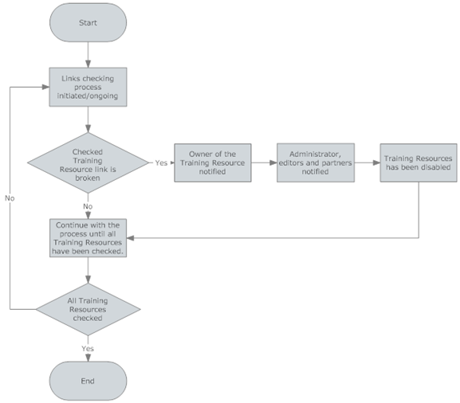
Figure 5. Automated Link Checking
When Training Resource has been disabled in the process of checking the links following users are notified:
- Administrator(s) of the Directory
- Editors who have:
Editorial access to the whole Directory
Editorial access to the Category to which Training Resource belongs/is cross-referenced
- Owner of the Training Resource
Checking the status of the Training Resource links (Resource URL; SEE ANNEX II) and disable all Training Resources whose links are broken

User Role Management
When a new user is registered, by default the system will assign member role to the user profile. It will be upto the authrorized user (e.g. Administrator or Editior) to assign role other than a member role to the user profile.

Portal and content management
OERTP will provide following portal and content management functionality:

OERTP homepage
OERTP homepage will be an entry point where different types of content and functionality will converge. It will contain following blocks:
- In focus
- Sets of categories (with their top level categories)
- Recommended Training Resources (editor’s choices)
- Latest News
- Upcoming Events
- Latest added resources
- Most popular Training Resources
- Latest comments
- Latest review
- UNESCO OERTP
- Follow US
- Directory Stats
- Community view

In focus
This block is HTML/text type of block. Editorial Access to this block can be assigned to particular user or user role.

Sets of categories
This block will contact dynamic list of top level UNESCO’s and global categories. It will also provide access to partner’s sets of categories. See wireframe document provided by UNESCO for additional description of the block functionality.
- User clicks on + icon next to global categories tab.
- System displays all list of partners will checkbox and partner image next to each partner.
- User can then select the one or more partners from the list and click save.
- System will show each selected partner as a tab next to the global categories tab.
- Clicking on the partner tab will display list of sets of categories created by the partner.
This is user specific view and will not get applied for all users

Recommended Training Resources (editor’s choices)
This block will contain list of Training Resources flagged as editor’s choice. Only users with administrator and editor role can set the Training Resources to be Editor’s choice.

Latest News
This block will contact mix of news items that are directly added to the platform and news items that are included via RSS feeds (block should provide input for specifying RSS feeds). Items will be listed together using the following sorting criteria: date (descending), name (ascending).

Upcoming events
This block will contact mix of events items that are directly added to the platform and events that are included via RSS feeds (block should provide input for specifying RSS feeds). Items will be listed together using the following sorting criteria: date (descending), name (ascending).

Latest added resources
This block will contain dynamic list of latest added Training Resources.

Most popular Training Resources
This block will contain the list of most popular Training Resources.
Polularity score should be a sum of following scores/values:
Number of resource page views multiply by 1.5
Number clicks on resource link multiply by 1.9
Number of comments multiply by 1.7
Average rating

Latest comments
This block will contain the list of latest users’ comments on the Training Resources

Latest reviews
This block will contain list of latest added Reviews of the Training Resources.

UNESCO OERTP
This block will contact news items from UNESCO OERTP site included via RSS feeds or manually uploaded using XML data.

Follow us
This block will contain link to popular social networking sites where OERTP site is registered. Some of them are given below. Administrator should have the ability to add more such links in future. It should also display the logo of these sites.
- Facebook
- Twitter
- MySpace

Directory Stats
This block will display OPT site statistics given below. Apart from this administrator should be able to manually add more data to this block.
- No of published training resources to OERTP site
- No of publish categories
- No of portal members
- OERTP site last updated

Community view
This block will provide a snapshot of community view. It will have two tabs
- Most Popular: This will display most popular comments posted.
- Latest Comments : This will display lasted comments posted to the site

Content elements
In addition to the Training Resources platform will also contain following content elements:
- Events
- News
- Reviews

Content pages
Platform will have several pages that will contain static HTML and text. Some of them are listed below. For placement of these links please refer to the wireframe document provided by UNESCO.
- Training on Demand
- Promote Us
- Web services
- About
- FAQ
- Glossary
- Contact
- Disclaimer
- Terms of Use
- Acknowledgment

Community
- Community members should see each other’s profiles (information flagged as public)
- Community member should be able to brows each other’s sets of categories.
- Community members should be able to send each other messages via the platform messaging engine (if member opts for receiving messages from other members)
- Members should be able to post their twitter like messages to the community

Non Functional Requirements

Directory web services layer
OERTP Platform will be designed to provide its functionality and content to the remote applications. This will be achieved using the web services layer.
OERTP platform will offer following functionality via its web services layer:
- Searching the Training Resources
- Browsing the Training Resources
List of client requests and services responses is available in the ANNEX VIII

Scalability and performance
UNESCO envisages a gradual increase in use of the Platform in the first two to three years. UNESCO wants to initially deploy technical infrastructure sized-down to the initial low level of use. As the Platform grows in content and number of users, UNESCO will size-up the underlying infrastructure. The Platform framework must support cost effective scalability techniques that will enable UNESCO to downsize/upsize technical infrastructure seamlessly and without downtime.

Accessibility
Many initiatives at the UN level require increasingly stringent rules on making content accessible to all. W3C rules are just a starting point in making OERTP content accessible. The service provider should be able to advise and assure that all developments comply with high accessibility standards.

Physical environment
Open Training Platform is used in several specific physical environments:
Office | Community, media and training centers | Home use | Mobile use
Restrictive connectivity and security rules | crowded environment  noise  pure lighting  Limited time for use  Connectivity interruptions  Low bandwidth | Connectivity interruptions  Low bandwidth | 3 G telephone  Other devices and readers

Social environment
- Platform’s content is created from different organizational levels (field offices, Central services, partners etc.)
- Platform’s content is subject to various workflow and validation processes

Organizational environment
- UNESCO has stable and well-developed communication infrastructure which ensures constant stream of information to the Portal.

Technical environment
OERTP content and information is based on the complex functional architecture that contains:

- CMS (Content management system) where content is presented through set of templating rules

User requirements
Conceptual models | Levels of skills
OERTP should provide following interaction conceptual models to users:  - Instructing  - Manipulating and navigating  - Exploring and browsing | OERTP is targeting vast variety of audiences with different user profiles and skills.  Users of all profiles have to be able to effectively use OERTP. Those profiles include:  - First time users  - Returning frequent users  - Novices (use of IT equipment, web browsers and interactive features)  - Experts (use of IT equipment, web browsers and interactive features)  - Users with disabilities

Usability requirements
Navigation | Page layout | Interactivity | Look and feel | Validation
- Effective and efficient  - Easy to learn  - Easy to remember how to use  - Affordable  - Consistent | - Have a good utility  - Consistent | - Effective and efficient  - Easy to learn  - Easy to remember how to use  - Safe to use (error recovery)  - Affordable  - Consistent | - Satisfying  - Aesthetically pleasing  - Helpful  - Motivating  - Emotionally fulfilling  - Consistent | CSS and HTML code must pass W3C validation tests:  - HTML validation: http://validator.w3.org/  - CSS validation: http://jigsaw.w3.org/css-validator/  - Browser validation (SEE ANNEX VII)

Multilingualism requirements

Language support
Deliverables must be fully functional (tested) in the following languages:
- English
- French
- Russian
- Spanish
- Chinese
- Arabic

Language of the final deliverable
The OERTP must be delivered in English.
While developing design elements contractor must take into consideration specificities of languages listed above (fonts availability, word and sentence length, text direction)

Supporting Information

Appendix A: List of all compatible web browsers
Browser | Operating system | Expected level of presentation | Point of reference (browser)
MS IE 10 | Windows | Full implementation | Chrome 31
MS IE 9 | Windows | Full implementation | Chrome 31
MS IE 8 | Windows | Moderate / High | Chrome 31
MS IE 7 | Windows | Moderate | Chrome 31
MS IE 6 | Windows | Basic | Chrome 31
Firefox 26 | Windows | Full implementation | Chrome 31
Firefox 25 | Windows | Full implementation | Chrome 31
Firefox 24 | Windows | Moderate | Chrome 31
Chrome 31 | Windows | Full implementation | Chrome 31
Opera 9 | Windows | Moderate / High | Chrome 31
Safari 4 | Mac OS | Full implementation | Chrome 31
Safari 3 | Mac OS | Full implementation | Chrome 31
Firefox 25 | Mac OS | Full implementation | Chrome 31
Firefox 26 | Mac OS | Full implementation | Chrome 31
Chrome 31 | Mac OS | Full implementation | Chrome 31
Opera 9 | Mac OS | Moderate / High | Chrome 31
Firefox 25 | Unix/Linux | Full implementation | Chrome 31
Firefox26 | Unix/Linux | Full implementation | Chrome 31
Chrome 31 | Unix/Linux | Full implementation | Chrome 31
Opera 9 | Unix/Linux | Moderate / High | Chrome 31

Appendix B: Data Requirements

Training Resource
Section | Property Name | Type | Interface note | Value(s) | Note | M/O | Create | Update | Delete | View
Technical | Resource Owner | Internal reference |  |  | Reference to the OERTP user who added the Training Resource to the Directory | - | U | U | U | U
General | Title | Text |  |  |  | Required | A | A | I | I
General | Description | Text | WYSIWYG |  |  | Required | A | A | I | I
General | Resource URL | Link |  |  |  | Required | A | A | I | I
General | Format | Predefined textual values |  | CD Rom  Online |  | Required | A | A | I | I
General | Language | List |  |  | List of predefined languages with other as an option to specify a new language if it is not available as part of predefined list. | Required | A | A | I | I
General | Producer | Text |  |  |  |  | A | A | I | I
General | Partners | Text |  |  | List of partners with other as an option to specify a new partner if it is not available as part of predefined list. |  | A | A | I | I
General | Year of production | Date | Date Picker |  |  | Required | A | A | I | I
General | Resource open | Predefined textual/Boolean values |  | Yes  No  Not Specified |  | Required | A | A | I | I
General | Ordering information | Text | WYSIWYG |  |  |  | A | A | I | I
Details | Skills | Text | WYSIWYG |  |  |  | A | A | I | I
Details | Type of License | Text |  |  | List of predefined values with other as an option to specify a new value if it is not available as part of predefined list. | Required | A | A | I | I
Details | License details | Text |  |  |  | Required | A | A | I | I
Details | Owner of License | Text |  |  |  | Required | A | A | I | I
Details | Contact | Text | WYSIWYG |  |  | Required | A | A | I | I
Details | IT literacy required | Text |  | Values to be specified |  | Required | A | A | I | I
Details | IT Equipment requirement | Text | WYSIWYG |  |  |  | A | A | I | I
Details | Keywords | Text |  |  | List of predefined values | Required | A | A | I | I
Details | User keywords | Text |  |  | Each user can add their own list of keywords |  | A | A | I | I
Details | Owner provided keywords (folksonomy) | Text |  |  |  | Required | A | A | I | I
Details | E-learning | Predefined textual/Boolean values |  | Yes  No |  |  | A | A | I | I
Details | Training level | Predefined textual values |  | Formal  Non-formal |  |  | A | A | I | I
Category | Sets of Categories/Category | Predefined Values |  |  | Display UNESCO defined sets of categories
M – Mandatory, A- Active, I – Inactive, U – Not Visible
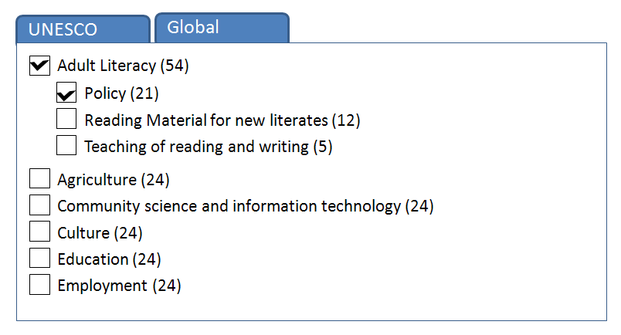
Figure 6. Sample Training Resource associated with “Adult Literacy”
In an example above, a new training resource is associated to “Adult Literacy” as one of the sets of categories under UNESCO defined sets of categories and “Policy” as category. The number next to sets of categories and category indicates number of published training resources associated to these sets of categories and category.

Sets of Categories
Property Name | Type | Form interface note | Value(s) | Note | Create | Edit | Delete
Name | Text |  |  | Required | A | A | I
Description | Text | Text box |  | Required | A | A | I
Visible to public | Predefined textual values | Radio box | Yes  No | Required | A | A | I
Promoted to homepage | Predefined textual values | Radio box | Yes  No | Required; manageable only by site administrators | A | A | I
Type | Predefined textual values | Drop-down menu | UNESCO  Global  User created | Required; manageable only by site administrators | A | A | I
Thumbnail | Image |  |  |  | A | A | I
Linked to user | Reference to the user who created a set of categories |  |  | Applicable only to set of categories created by users | A | A | I
Subscribe | Predefined textual values | Radio box | Yes  No | Subscribe to be notified when new added Training Resource matches one of the categories in the set of categories; Applicable only to set of categories created by users | A | A | I

Category
Property Name | Type | Form interface note | Value(s) | Note | Create | Suggest | Update | Delete | Validate
Name | Text |  |  | Required | A | A | A | I | I
Description | Predefined textual values | Radio box | Yes  No | Required | A | A | A | I | I
Keywords | Text |  |  |  | A | A | A | I | I
Categories | Tree view with selection |  | Sets of categories and category | In case of suggest, it will only display UNESCO defined sets of categories and category | A | A | A | I | I

User
Property Name | Type | Form interface note | Value(s) | Note | Register | Edit Profile | View Profile
Username | Internal reference |  |  | Required | A | A | I
Password |  |  |  | Required | A | A | I
E-mail |  |  |  | Required | A | A | I
Fist Name | Text |  |  | Required | A | A | I
Last Name | Text |  |  | Required | A | A | I
Gender | Predefined textual values |  | Male  Female |  | A | A | I
Birthday | Date | Date picker |  |  | A | A | I
Address |  |  |  |  | A | A | I
City |  |  |  |  | A | A | I
State |  |  |  |  | A | A | I
Postal code |  |  |  |  | A | A | I
Country |  |  |  |  | A | A | I
Organization/company |  |  |  |  | A | A | I
Job title |  |  |  |  | A | A | I
Type of occupation | Predefined textual values |  |  | Required | A | A | I
Working Phone | Text |  |  |  | A | A | I
Mobile Phone |  |  |  |  | A | A | I
Description | Text | WYSIWYG |  |  | A | A | I
Interests |  |  |  |  | A | A | I
Website | Link |  |  |  | A | A | I
Partner type | Predefined textual values | Radio box | - Certified Partner  - Non Certified Partner | manageable only by site administrators
Partner Sub type | Predefined textual values | Dropdown | - Premium Partner  - UN Partners  - Associated Partners  - Open Partners | Required, if partner type is selected.  manageable only by site administrators
Partner Description | Test |  |  | manageable only by site administrators
Partner Logo | Image |  |  | Required, if partner type is selected.  manageable only by site administrators

Comment
Property Name | Type | Form interface note | Value(s) | Note | Post | Validate | Delete | View
Title | Text |  |  | Required | A | I | I | I
Description | Text | WYSIWYG |  | Required | A | I | I | I
User Photo | Image |  |  |  |  | I | I | I
Name (Last Name, First Name) | Hyperlink | Hyperlink to user profile page |  | Name of the user submitting comment | U | I | I | I
Time Stamp (Date, Time) | Label |  |  | Time Stamp for the comment submitted | U | I | I | I

Event
Property Name | Type | Form interface note | Value(s) | Note | Add | Edit | Delete | View
Title | Text |  |  | Required | A | A | I | I
Description | Text |  |  | Required | A | A | I | I
Event Logo | Image | Default logo to provided |  |  | A | A | I | I
From Date | Date | Date Picker |  | Required | A | A | I | I
To Date | Date | Date Picker |  | Required | A | A | I | I
Full Day Event | CheckBox |  |  |  | A | A | I | I
Time Stamp | Label | Date and Time |  |  | U | U | I | I
Create By | Label | Name of the user | Last Name, First Name |  | U | U | I | I

News
Property Name | Type | Form interface note | Value(s) | Note | Add | Edit | Delete | View
Title | Text |  |  | Required | A | A | I | I
Description | Text |  |  | Required | A | A | I | I
Time Stamp | Label | Date and Time |  |  | U | U | I | I
Create By | Label | Name of the user | Last Name, First Name |  | U | U | I | I

Review
Property Name | Type | Form interface note | Value(s) | Note | Add | Edit | Delete | View
Title | Text |  |  | Required | A | A | I | I
Description | Text |  |  | Required | A | A | I | I
Rating
Time Stamp | Label | Date and Time |  |  | U | U | I | I
Create By | Label | Name of the user | Last Name, First Name |  | U | U | I | I

Personal Message
Property Name | Type | Form interface note | Value(s) | Note | Post Message | Delete | View
Title | Text |  |  | Required | A | I | I
Description | Text | WYSIWYG |  | Required | A | I | I
User Photo | Image |  |  |  |  | I | I
Name (Last Name, First Name) | Hyperlink | Hyperlink to user profile page |  | Name of the user submitting comment | U | I | I
Time Stamp (Date, Time) | Label |  |  | Time Stamp for the comment submitted | U | I | I

5.3 Appendix C: Change log history
Please refer to Configuration Manager as the change history is regularly updated in “GitLab” Configuration Manager.

